Isomerization of   
Mercury Dithizonate

Excitation wavelength: <500 nm, CG-BG-3

Observation wavelength: 600 nm

Chemicals needed

* ~10–5 M mercury dithizonate (HgDz)
* 0.01 M trifluoroacetic acid (TFA)
* ethanol, commercial grade for solvent

Hardware and software needed

* Vernier Flash Photolysis Spectrometer software (available for Windows® only)
* computer
* Vernier Flash Photolysis Spectrometer
* fluorescence cuvette

Background

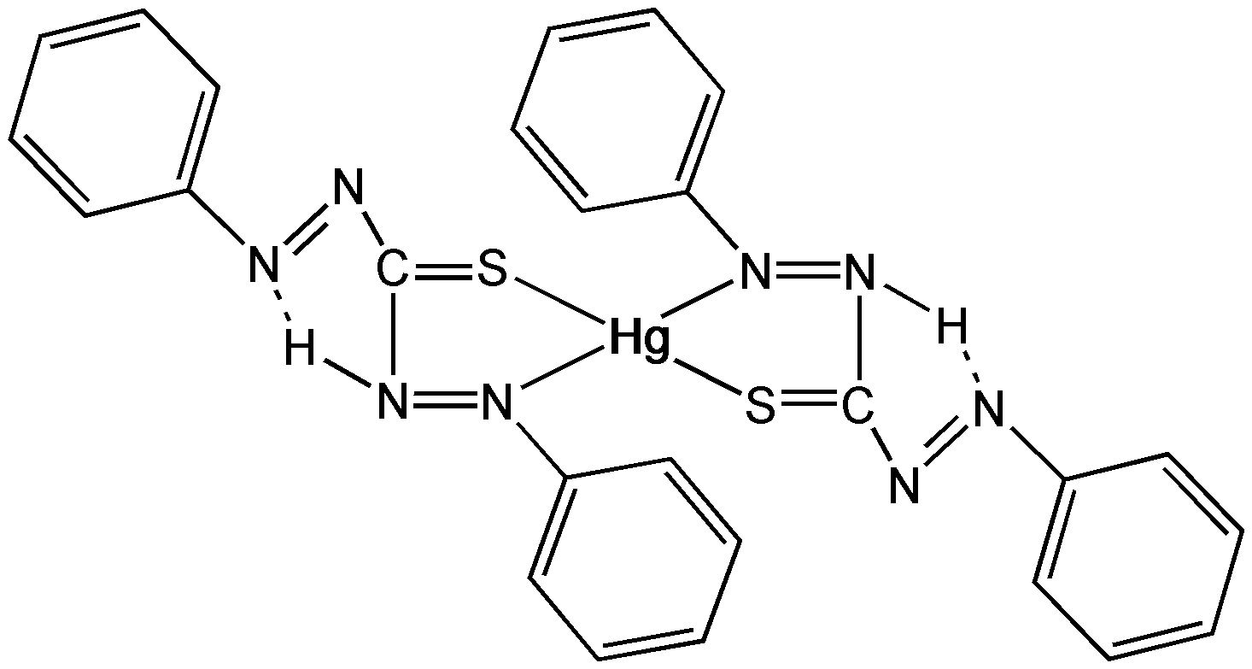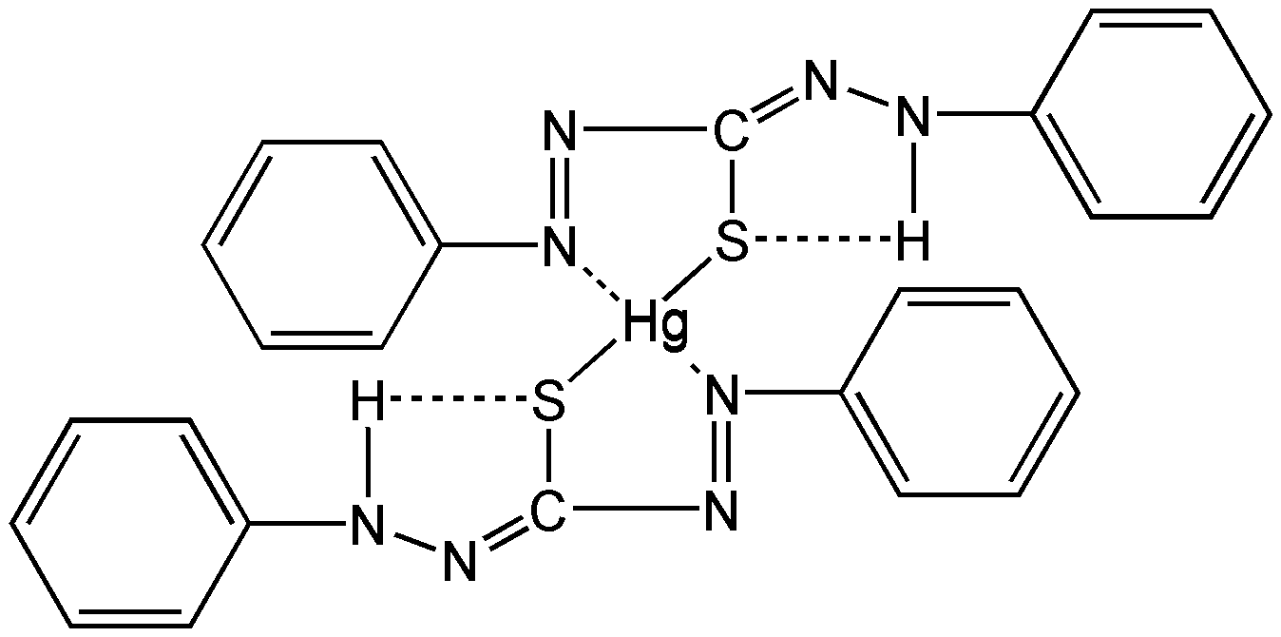

**Figure 1:** Photoinduced isomerization of mercury dithizonate

This photoisomerization event occurs within the flash lamp profile (i.e., “instantaneously” on our time scale). The trans-to-cis back reaction occurs in the dark period following the flash, and the color reverts thermally with a lifetime of ~650 ms. This inversion of color can be catalyzed by acids and bases. In this experiment, the solution of the HgDz complex is excited by the flash lamp and the decay of the transient absorption at 600 nm is monitored as a function of time after the flash.

The decay is exponential in time with a rate that is first order in the concentration of an acid such as trifluoroacetic acid (TFA, Figure 3). The experimental conditions are such that the TFA is at a much higher concentration than the photo-produced trans-isomer of the complex and so the conditions correspond to the pseudo-order situation as described in the kinetics theory section (Section 10.3 of the reference manual). A plot of the observed rate constant as a function of acid concentration is linear with a slope that provides the bimolecular rate constant for the catalysis process.

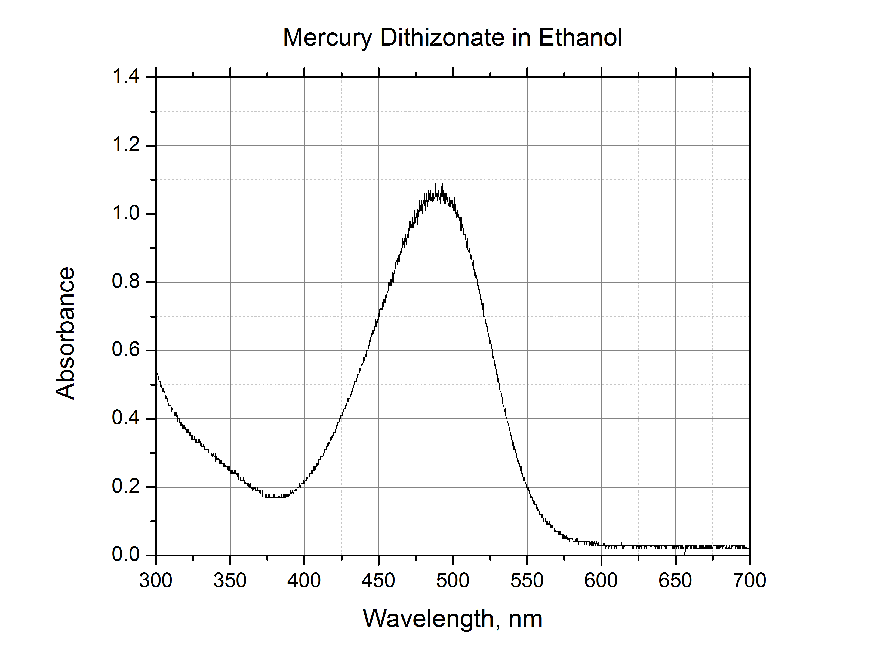

**Figure 2:** Ground state absorption spectrum of mercury dithizonate (trans conf.) in ethanol

Procedure

Obtain and wear goggles. Prepare a 25 mL stock solution of HgDz in ethanol with sufficient solute to provide absorbance of ~1 in a standard cm2 at 500 nm (roughly 10-5 M). Prepare 25 mL of 0.01 M stock solution of TFA in ethanol. Prepare at least five sample solutions, each containing 3 mL of HgDz stock, aliquots of TFA stock in the range of 0–1 mL, and sufficient ethanol to bring total volume to 4.0 mL. These sample solutions will all have the same concentration of HgDz and varying concentrations of TFA in the range 0–0.02 M TFA. Place ~4 mL of the [TFA] = 0 M sample solution in a 10 mm x 25 mm rectangular borosilicate cuvette with all faces polished and proceed to photoexcitation. Ensure you have connected the Vernier Flash Photolysis Spectrometer to your computer using the Vernier Flash Photolysis Spectrometer software. Insert the CG-BG-3 dielectric filter and the 600 nm band pass filter.

Photoexcitation of an air-saturated ethanol solution of the Hg complex with the dithizone ligand in the cis-form induces cis-to-trans isomerization, and the compound changes color from orange to blue (λmax = 605 nm).

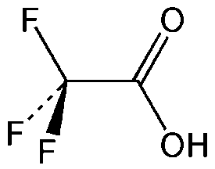

**Figure 3:** Trifluoroacetic acid (TFA); MW = 114.03

In Figure 4, you can see that the flash at t = 0 causes a vertical (on these time scales) drop in the Probe Intensity reading; ignoring the large spike and looking at data after 100 μs, it drops from ~29.98 μA prior to the flash to ~29.85 μA after the flash. Subsequently, the value increases over hundreds of milliseconds. The flash induces the changes outlined earlier, and very quickly, at shorter times than software can follow, the ground state of the cis-form is generated. After reviewing the scanned data, the half-life for this sample is ~300 ms. Importing the data into data-analysis software such as Logger *Pro* will allow for the determination of the trans-cis isomerization rate constant with greater accuracy. Repeating this process at the various concentrations of TFA will show a linear dependence of the lifetime on acid concentration.

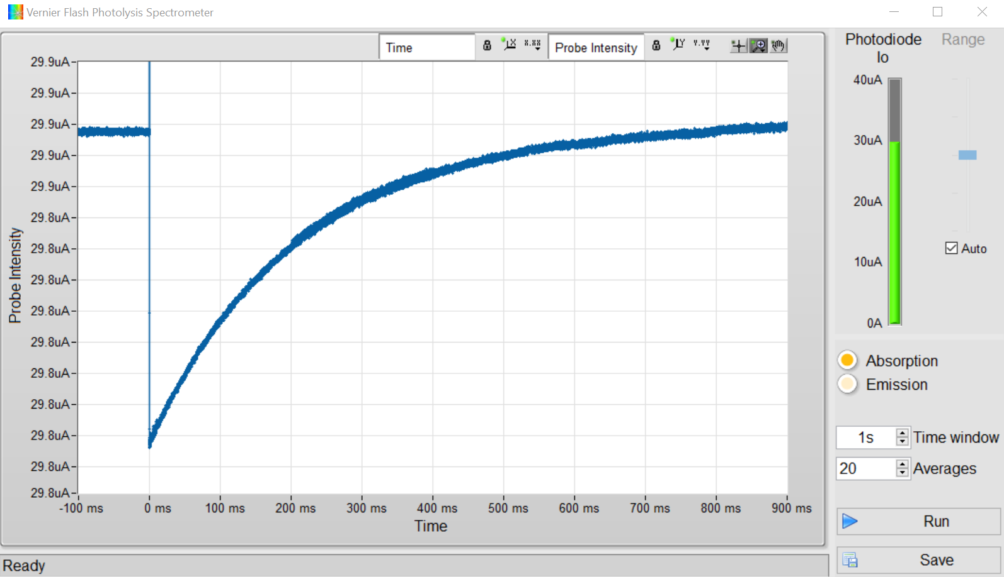

**Figure 4:** Kinetic profile of mercury dithizonate in ethanol