Color Mixing
The light we perceive as “white” light is made of a combination of wavelengths throughout the range of the electromagnetic spectrum known as the visible spectrum. The visible spectrum ranges from 390 to 750 nm. However, the human nervous system is not equally sensitive to all wavelengths in that range. This is due to the physiology of the photoreceptor cells in the eye.
There are three types of rod cells, each with a different range of light sensitivity. The wavelengths of peak sensitivity for each of these three kinds of cells correspond to red, green and blue light. The human nervous system interprets combinations of signals from these three types of cells, allowing us to perceive a wide array of colors.
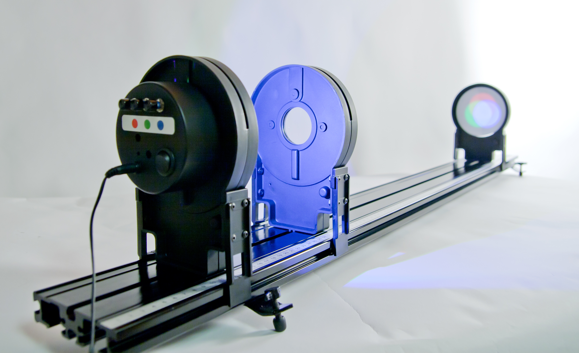
Figure 1

objectives
- Observe the characteristics of colors produced by additive mixing of light.
- Observe the characteristics of colors produced by subtractive mixing of light.
- Understand the relationship between the physiology of the eye and the physics of color.

Materials
Vernier Color Mixer Kit | Toothpicks (1 per group)
Vernier Dynamics Track | Masking tape or sticky notes

Procedure
Part A: Additive Mixing
Set up the Vernier Dynamics Track and Color Mixer Kit: Place the three-color LED illuminator at 10 cm, the 20 cm double convex lens at 25 cm, and the screen at 80 cm, with the white side facing the illuminator and lens.
1. Turn on the light source and adjust it so all three color LEDs are illuminated. Adjust the intensity of the individual LEDs until the area in the center of the color pattern appears white.
2. Observe the color pattern. Sketch and label a diagram of the colors seen on the screen. What are the “primary” colors (those found at the outer edge)?
3. The secondary colors are cyan, magenta, and yellow. Where do they occur? Which colors mix to make each?
Secondary Color | Is produced by adding:
Cyan
Magenta
Yellow

4. Predict what will happen to the pattern when you turn off the red LED. Which colors will remain? Which color will occur in the center?
5. Test your prediction by turning off the red LED. Sketch and label a diagram of the colors seen on the screen. Which colors disappear, and which remain? How did your results compare with your predictions?
6. Remove the lens from the track. Use the three LED adjustment knobs to change the color mix and produce new colors. What new colors can you produce? For each new color, describe how it is produced. Which primary colors are used and in what intensities?

Part B: Subtractive Mixing
7. Review the results you found when you turned off the red LED in step 5.
8. Imagine white light striking a piece of paper that absorbed all the red light and reflected other wavelengths. What color would your eye detect when taking in the reflected light?
The example in step 8 explains how pigments in paint dyes and other materials work. Pigments have unique molecular structures which cause the selective absorption of some wavelengths of light.
9. Replace the lens. Turn on the light source and adjust it so all three color LEDs are illuminated.
10. Place a piece of tape or sticky note on the end of a toothpick making a flag for casting a shadow on the screen. The width of the piece of tape or sticky note should be about 1.5 cm. Hold the toothpick and flag between the lens and the screen. Sketch and label a diagram of the colors seen on the screen. Observe the pattern produced. What colors do you see and where are they located?
It is important to understand that this subtractive color pattern is different from the additive color pattern produced in Part A. While an additive pattern combines light of different colors to make white light, the subtractive pattern is produced by removing component colors from white light. It is helpful to think of the piece of tape as blocking or filtering out some of the light from the source. In different places on the screen, different colors are filtered out.
11. What color do you expect to see where red light is subtracted, and blue and green are present? Turn off the red light. Sketch and label a diagram of the colors seen on the screen.
12. What color do you expect to be produced by blocking or filtering blue light while the red and green lights are on? Turn off the blue LED. Sketch and label a diagram of the colors seen on the screen. What color can you say is produced by removing blue light from white light? Is this the same result as when you added red and green light in Part A?
13. What color do you expect to be present when green light is subtracted from white light? Confirm your conclusions by turning off the green LED and leaving the blue and red lights on. Sketch and label a diagram of the colors seen on the screen.
The three colors you identified in steps 11, 12, and 13 are the primary colors of subtractive color mixing of light. These are also the primary colors used when combining pigments and dyes. By combining pigments of these three colors, we can produce other colors. This is because the primary pigments absorb light with wavelengths in one of the three regions of the visible spectrum for which humans have sensitive cone receptors.
14. In the table below, identify the wavelength of light that is subtracted from white by each of the primary pigments.
Subtractive Primary | Is produced by subtracting
Cyan
Magenta
Yellow

15. Which two primary pigments could you use to produce a red color? If you think of pigments as filtering out colors, which two colors need to be filtered from white light to result in red light? This will likely agree with what you have learned from mixing paint in art class. Red is a subtractive secondary color because it results from mixing two primary pigments.
Inkjet printer cartridges often produce color by mixing three pigments of ink: cyan, magenta, and yellow. (They often also use black ink for black and white printing and for shading.) A paint store uses a white base paint mixture and a computer which measures out pigments to produce a dizzying array of colors.
16. Convince yourself that you could produce any color you wish by starting with white light produced by the three LEDs of the light source and subtracting colors. Turn down one or more of the LED lights to create new colors. Can you produce orange? What other interesting colors are you able to produce, and what adjustments did you make to produce them?

Part C: Colored Dots
17. Reverse the orientation of the screen on the track so the side with the dots is facing the light source and lens. Notice the pattern of colored marking dots. Remove the lens from the track. Shine “white” light on the screen by turning on the red, green, and blue LEDs.
18. Slowly turn down the red LED. Observe the dots. Which dots are most affected by the change? How do they change and why?
19. Try the same change for each of the LEDs while the other two LEDs are shining. What do you observe?
20. What happens when you only turn on the red LED? How do the red dots appear against the black background? How do they appear against the white background?
21. Repeat Step 20 for the other LEDs. How do the red dots appear against the black background? How do they appear against the white background?
22. Turn off all the LEDs and look at the yellow dots. Now try just the red LED. What is the appearance of the yellow dot under red light? Blue? Green? Explain what is happening.

Checking For Understanding
When thinking about color mixing, it is helpful to think about how colors are added as well as what happens when some colors are subtracted (absorbed by pigments). These two phenomena are called additive and subtractive mixing.
1. The drama department wants to use stage lighting to produce a magenta color. They have red, green, and blue lights. How will you adjust the lights to produce this color? Why?
2. You are helping the drama department create a green backdrop for a play. You can mix any combination of cyan, magenta, and yellow paints. Which paints will you use? Why?
3. Your physics teacher and your art teacher may give different responses when you ask them which colors are primary. Why might that be?

Extensions
1. Can you use the light source to produce a brown color on the screen? Search online for the RGB web color values of brown. The numbers in the RGB scale range from 0 to 255 and tell you relatively how much red, green, and blue light sources are combined to make a pixel of a given color. Try adjusting the LEDs to get brown, using this set of values as a guide.
2. Perform a search online for “primary colors.” Does every source give three unique colors? Do different sources give the same colors? How can you explain these different perspectives?

Color Mixing
This experiment needs to be done in a darkened room for the best results.
objectives
- Observe the characteristics of colors produced by additive mixing of light.
- Observe the characteristics of colors produced by subtractive mixing of light.
- Understand the relationship between the physiology of the eye and the physics of color.

Sample results
Part A: Additive Mixing
Steps 1 – 2
The primary colors (found on the edge of the white center region) are red, green and blue.

Step 3
Secondary Color | Is produced by adding:
Cyan | Blue and green
Magenta | Red and blue
Yellow | Red and green

Step 4
Student answers may vary.

Step 5
Red, magenta, yellow and white disappear. Blue, green and cyan remain. The color of the center of the pattern is cyan. These remaining colors do not include any red light.

Step 6
Student answers may vary.

Part B: Subtractive Mixing
Steps 7 – 8
Cyan

Step 9 – 10
Student answers may vary.

Step 11
Cyan

Step 12
Yellow. Yes, this is the same result as adding red and green light.
Step 13
Magenta

Step 14
Subtractive Primary | Is produced by subtracting
Cyan | Red
Magenta | Green
Yellow | Blue

Step 15
Yellow and magenta produce red.

Step 16
Student answers may vary. Orange is composed of red along with some blue and green light.

Part C: Colored Dots
Steps 17 – 18
Red dots get darker because they don’t have red light to reflect.

Steps 19 – 20
The red dots appear bright against the black background, and contrast less with the white background.

Steps 21 – 22
The yellow dots look nearly red under red light, green under green light, and very dark under blue light because the yellow pigment absorbs blue light and reflects much of the red and green light.

Checking For Understanding—Sample Results
1. Use red and blue lights.
2. Cyan paint to absorb red light and yellow to absorb blue. The resulting color will be green.
3. The physics teacher may refer to additive color mixing while the art teacher uses pigments to work with subtractive mixing.

Extensions
1. A good reference is the Wikipedia article, Web colors: https://en.wikipedia.org/wiki/Web_colors
The web color RGB values for brown are 165, 42, and 42. Students should be able to adjust the red, green and blue LEDs accordingly to get something that resembles brown. Students may notice that an additive mix to produce brown looks somewhat different than a subtractive mix produced by pigments.
2. Student answers may vary.

